Diagram

[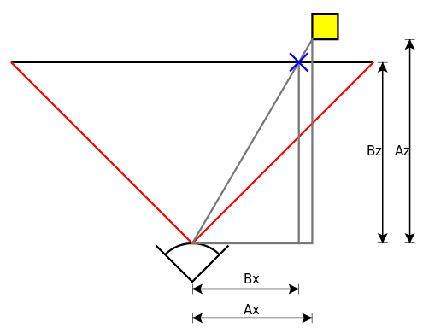](http://en.wikipedia.org/wiki/File:Perspective_transform_diagram.svg)

To determine which screen *x*-coordinate corresponds to a point at A_x,A_z multiply the point coordinates by:

B_x = A_x \frac{B_z}{A_z}

where

B_x is the screen *x* coordinate

A_x is the model *x* coordinate

B_z is the [focal length](http://en.wikipedia.org/wiki/Focal_length)—the axial distance from the [camera center](http://en.wikipedia.org/wiki/Camera_center) to the [image plane](http://en.wikipedia.org/wiki/Image_plane)

A_z is the subject distance.

Because the camera is in 3D, the same works for the screen *y*-coordinate, substituting *y* for *x* in the above diagram and equation.

http://en.wikipedia.org/wiki/3D\_projection